LAB # 14
MUTABILITY AND IMMUTABILITY
OBJECTIVE:
Understanding and implementing the concept of mutability and immutability.
LAB TASK 01 :
CODE :
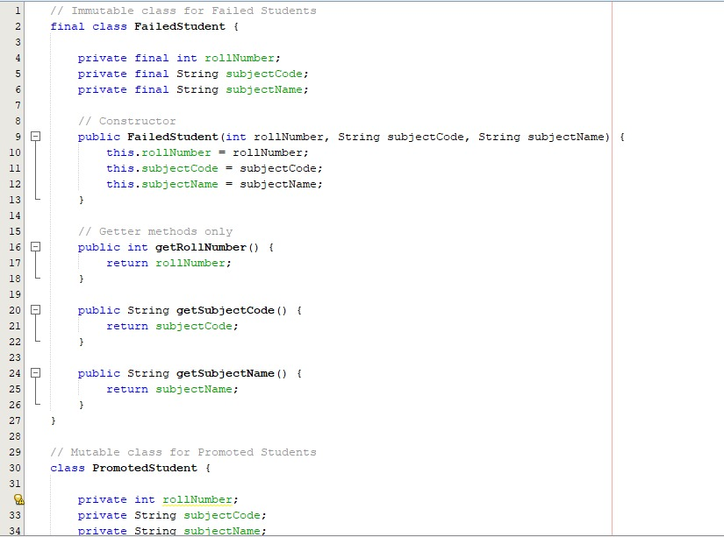
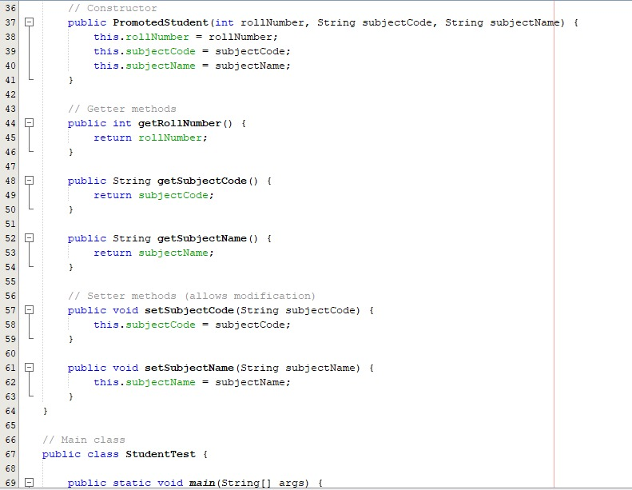
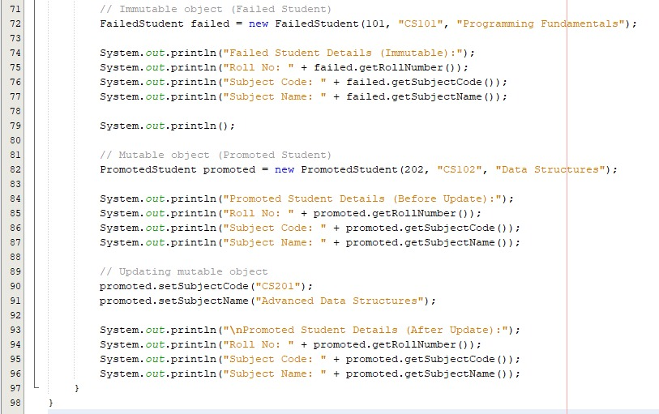

OUTPUT :
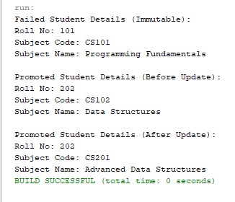
LAB TASK 02 :
CODE :


OUTPUT :
